The heredity units what we call genes today, were proposed by Mendel as "__________"
A. elementens
B. Items
C. Gene pool
D. Antigen
ANSWER: A
________introduced the term "gene"
A. Walther
B. Weldeyer
C. Wilhelm Johansson
D. Corren
ANSWER: C
Wilhelm Johansson introduced the term "gene" for the basic unit of heredity in
A. 1789
B. 1909
C. 1456
D. 1899
ANSWER: B
"_________" the basic unit of heredity
A. Alleles
B. Genes
C. Gene pool
D. Antigen
ANSWER: B
______ are the basic units of inheritance
A. Alleles
B. Genes
C. Gene pool
D. Antigen
ANSWER: B
Chromatids of two different homologous chromosomes are called
A. Sister chromatids
B. Non-sister chromatids
C. Homologous chromosome
D. None of these
ANSWER: B
The ______ pairs contain both morphologically similar members with same set of genes
A. Homologous
B. Analogous
C. Heterogeneous
D. None of these
ANSWER: A
Alternative form of the same gene in a population at any one time is called ____
A. Genotype
B. Phenotype
C. Locus
D. Alleles
ANSWER: D
The total aggregate of genes in a population at any one time is called ____
A. Genotype
B. Phenotype
C. Gene pool
D. Alleles
ANSWER: C
Wilhelm Johansson introduced the term ________
A. Alleles
B. Genes
C. Gene pool
D. Antigen
ANSWER: B
Allele is:
A. Alternative form of the gene on the same locus
B. Unit of heredity
C. Location of a specific gene on chromosome
D. None of these
ANSWER: A
Locus is:
A. Alternative form of the gene on the same locus
B. Unit of heredity
C. Location of a specific gene on chromosome
D. None of these
ANSWER: C
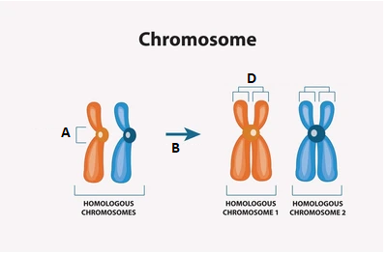
What does A represent in the given diagram?
A. replication
B. sister chromatids
C. chromatids
D. centromere
ANSWER: D

What does B represent in the given diagram?
A. replication
B. sister chromatids
C. chromatids
D. centromere
ANSWER: A

What does D represent in the given diagram?
A. replication
B. sister chromatids
C. chromatids
D. centromere
ANSWER: B

